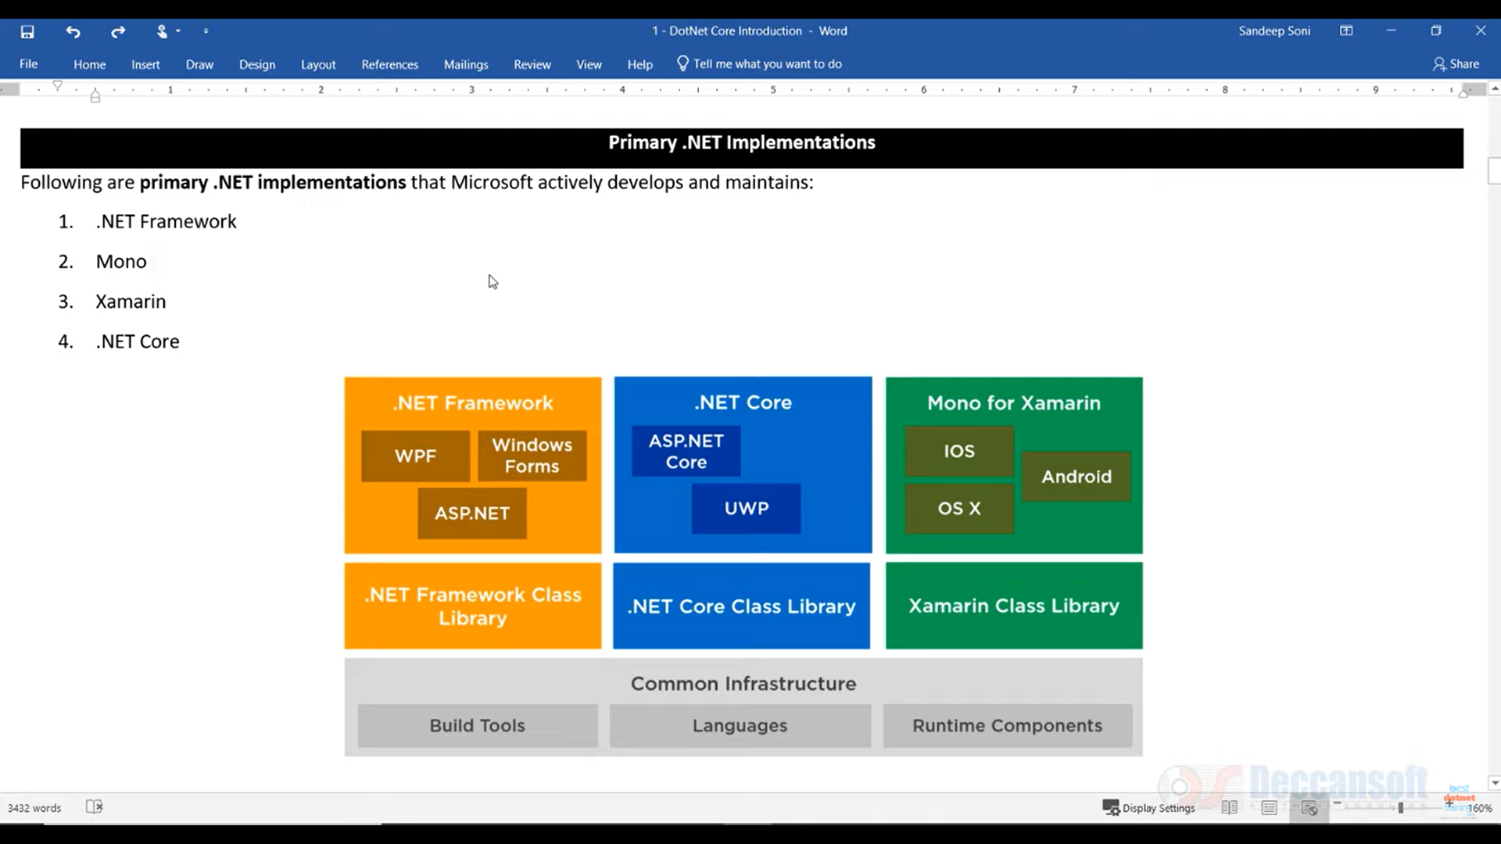

Net Standard Libraries

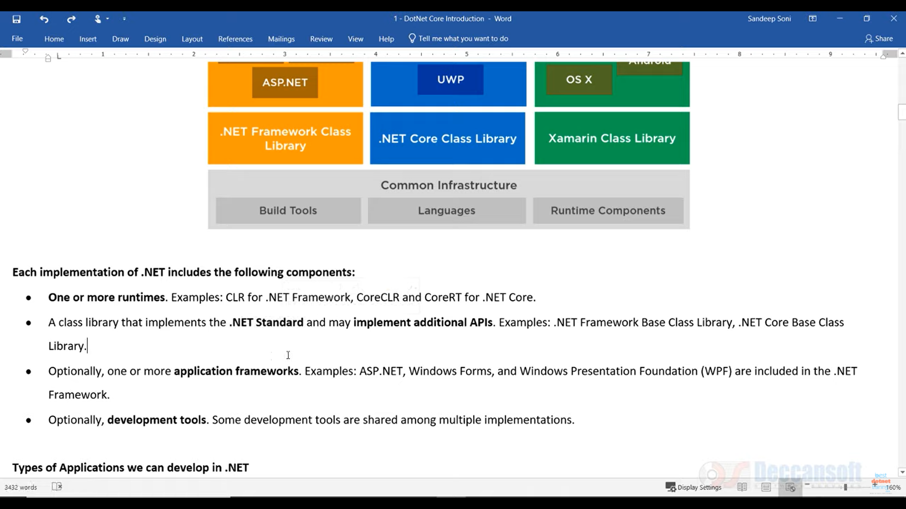

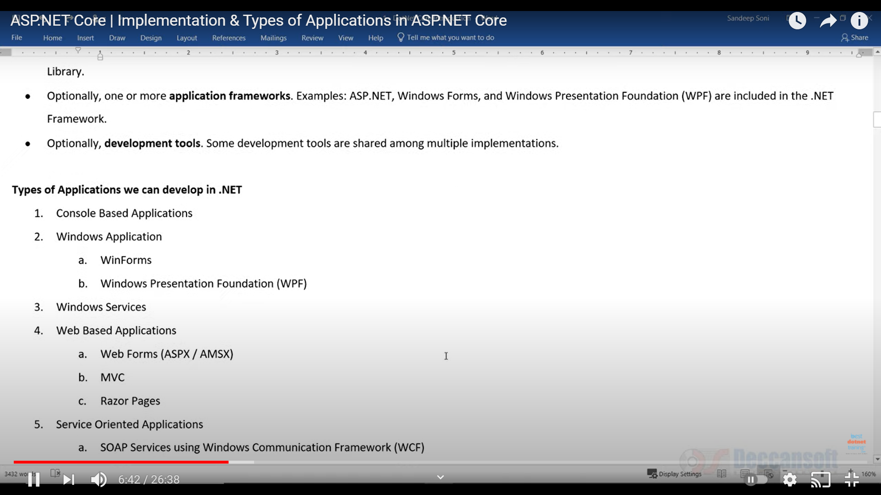

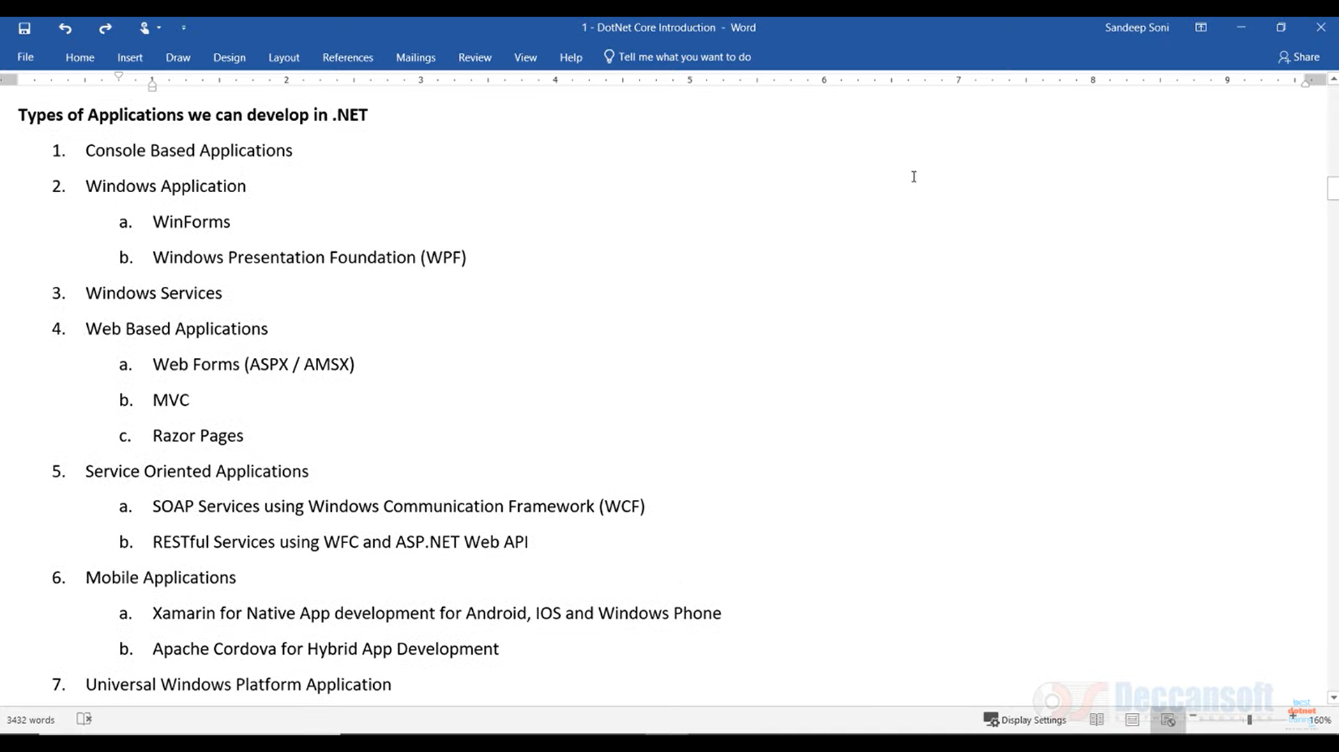

Window Services

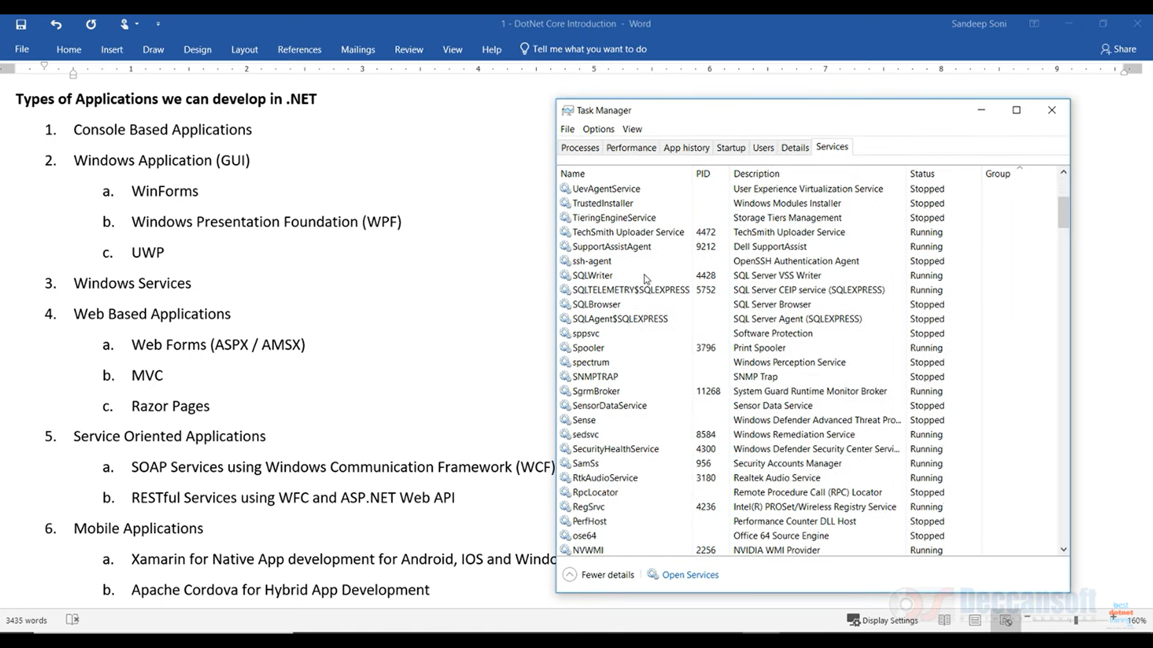

Which are running in background

They don’t have any UI

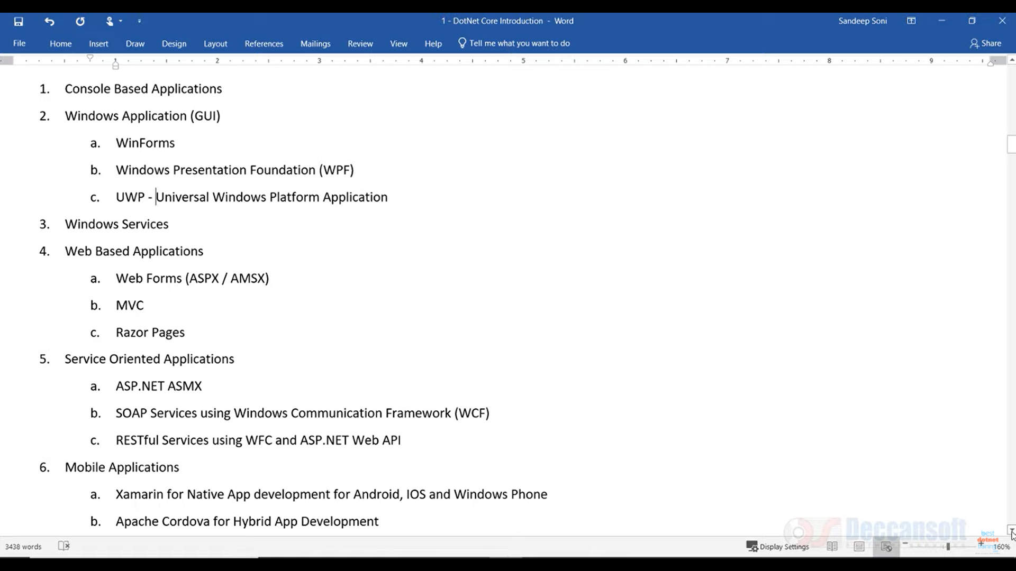

We cannot use DotNet to make System Applications, Any applicatiob which directly intercarts with harsware

Primary .NET Implementations Following are primary .NET implementations that Microsoft actively develops and maintains: 1. .NET Framework 2. Mono 3. Xamarin 4. .NET Core Each implementation of .NET includes the following components: • One or more runtimes. Examples: CLR for .NET Framework, CoreCLR and CoreRT for .NET Core. • A class library that implements the .NET Standard and may implement additional APIs. Examples: .NET Framework Base Class Library, .NET Core Base Class Library. Types of Applications we can develop in .NET 1. Console Based Applications 2. Windows Application (GUI) 3. Windows Services 4. Web-Based Applications 5. Service-Oriented Applications 6. Mobile Applications .NET Runtimes: Runtime is the execution environment for a managed program. The OS is part of the runtime environment but is not part of the .NET runtime. Here are some examples of .NET runtimes: • Common Language Runtime (CLR) for the .NET Framework • Core Common Language Runtime (CoreCLR) for .NET Core .NET Compilers: • Roslyn is a compiler platform and includes the C# and VB compilers and other tools. These compilers emit Common At release, the entire .NET Framework will be compiled using Roslyn. • .NET Native compiles C# and VB to native machine code that performs like C++, so developers continue to benefit from the productivity and familiarity of the .NET Framework with the performance of native code. Typically, apps that target .NET are compiled to intermediate language (IL). At run time, the just-in-time (JIT) compiler translates the IL to native code. In contrast, .NET Native is an ahead-of-time compiler that compiles apps directly to native code and contains a minimal CLR runtime. Popular Windows Store apps start up to 60% faster and use 15-20% less memory when compiled with .NET Native. Universal Windows apps will run on .NET Native (ARM, x86, x64). See: Compiling Apps with .NET Native